CHILDREN’S BULLETIN:
Luke 24:13-35
“Blessings in Disguise”
Memory Verse: And their eyes were opened, and they recognized him. And he vanished from their sight. They said to each other, “Did not our hearts burn within us while he talked to us on the road, while he opened to us the Scriptures?” Luke 24: 31-32

Sometimes we can get confused and perplexed by what happens to us, and it takes a while to understand what God is doing for us. Even in the Bible, people did not always recognize the signs God gave them. He sent prophets to explain things that would happen, but even when the signs they told came true, not everyone understood. After Jesus rose from the dead, He visited people, but they did not always know right away who He was. Now, it is possible that Jesus looked a little bit different after the Resurrection. It is also possible that people were not expecting Him to be alive, and did not understand what God had done, even though Jesus Himself had told them what would happen. A couple of disciples were walking along a road, and they were feeling sad that Jesus had died. Jesus showed up and started walking with them, but they did not know right away that it was Him. He started asking questions about what they were discussing, and they explained how upset they were over the death of Jesus. Then Jesus started to describe to them how the prophets and Scripture had predicted what would happen. He told the disciples about Himself! Well, they invited Jesus to stay for supper, and as He was breaking the bread, they suddenly realized who He was! Their eyes were open, and they were filled with joyful enthusiasm. Sometimes things in our lives are disguised, in a way. We do not always recognize or understand things that God is doing. We might encounter difficult situations or circumstances and feel confused about why God would allow something like that to happen. We can trust that God is at work, but we might still face challenges. We will not always find out right away why we have such trouble in our lives. We might not even understand until Heaven. But God promises that He is working things for our good. We cling to the hope that even hard things can bring blessings. We can also cling to the best news of all: unlike the disciples on the road, we do know that Jesus came back to life. We have the whole picture of the Bible, and we know that He was sent by God to die and come back to life, so that we can have eternal life with Him! We rest assured that our sins are covered, and that one day all things will be made new. Meanwhile, we can keep an eye out for blessings. We remain in prayer and Bible study every day, so that we will not miss out on the work God does in our lives. We recognize that sometimes God uses other people around us, as well as situations and circumstances, and that He is demonstrating love and strengthening us, even when things are tough. He is faithful and steadfast, so we can gain strength and hope in Him!

Dear God,
Thank you that we can celebrate Jesus. Thank you for all He did for us
And all that He continues to do. Help us to trust in you
Even when we do not understand what is happening. We know you work things for good
Thank you for your love. We love you, God!
In Jesus name, Amen!
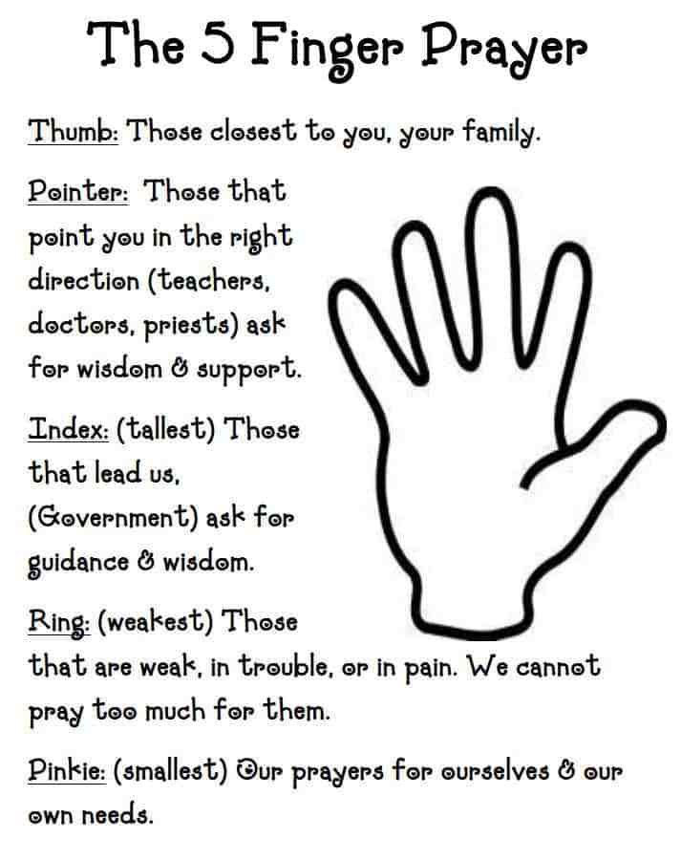

CHILDREN’S BULLETIN:
Luke 24:13-35
“Blessings in Disguise”
Memory Verse: And their eyes were opened, and they recognized him. And he vanished from their sight. They said to each other, “Did not our hearts burn within us while he talked to us on the road, while he opened to us the Scriptures?” Luke 24: 31-32

Sometimes we can get confused and perplexed by what happens to us, and it takes a while to understand what God is doing for us. Even in the Bible, people did not always recognize the signs God gave them. He sent prophets to explain things that would happen, but even when the signs they told came true, not everyone understood. After Jesus rose from the dead, He visited people, but they did not always know right away who He was. Now, it is possible that Jesus looked a little bit different after the Resurrection. It is also possible that people were not expecting Him to be alive, and did not understand what God had done, even though Jesus Himself had told them what would happen. A couple of disciples were walking along a road, and they were feeling sad that Jesus had died. Jesus showed up and started walking with them, but they did not know right away that it was Him. He started asking questions about what they were discussing, and they explained how upset they were over the death of Jesus. Then Jesus started to describe to them how the prophets and Scripture had predicted what would happen. He told the disciples about Himself! Well, they invited Jesus to stay for supper, and as He was breaking the bread, they suddenly realized who He was! Their eyes were open, and they were filled with joyful enthusiasm. Sometimes things in our lives are disguised, in a way. We do not always recognize or understand things that God is doing. We might encounter difficult situations or circumstances and feel confused about why God would allow something like that to happen. We can trust that God is at work, but we might still face challenges. We will not always find out right away why we have such trouble in our lives. We might not even understand until Heaven. But God promises that He is working things for our good. We cling to the hope that even hard things can bring blessings. We can also cling to the best news of all: unlike the disciples on the road, we do know that Jesus came back to life. We have the whole picture of the Bible, and we know that He was sent by God to die and come back to life, so that we can have eternal life with Him! We rest assured that our sins are covered, and that one day all things will be made new. Meanwhile, we can keep an eye out for blessings. We remain in prayer and Bible study every day, so that we will not miss out on the work God does in our lives. We recognize that sometimes God uses other people around us, as well as situations and circumstances, and that He is demonstrating love and strengthening us, even when things are tough. He is faithful and steadfast, so we can gain strength and hope in Him!

Dear God,
Thank you that we can celebrate Jesus. Thank you for all He did for us
And all that He continues to do. Help us to trust in you
Even when we do not understand what is happening. We know you work things for good
Thank you for your love. We love you, God!
In Jesus name, Amen!
